SOCIAL MEDIA TOOLKIT

Midwifery for Educators: #IntroduceMidwifery
Call to Action
The term “midwife,” (mid-wife) originates from old English, meaning with woman. Midwives are health care providers that provide care during pregnancy, childbirth, and the postpartum period—and also provide reproductive and primary health care at every life stage, including routine gynecologic care, annual exams, family planning services, and contraception education. Midwives use the midwifery model of care, which is a philosophy that views pregnancy and childbirth as normal life events and emphasizes person-centered care.
Although midwives are an essential part of the health care workforce, their work is often misunderstood, underused, and undervalued. The United States has the highest maternal mortality rates of any high-income country. In New Jersey, a Black woman is seven times more likely to die of pregnancy or birth issues than a white woman, and a Black baby is three times more likely than a white baby to die before their first birthday. In most of the higher income countries with better maternal health outcomes, midwifery-led care is the norm. Here in New Jersey, midwives have a key role in eliminating the state’s intolerable disparities.
This toolkit provides key messages and sample social media posts to empower educators to introduce midwifery as a career option to students of all backgrounds, nationalities, gender identities, and life experiences. Introducing the midwifery profession at an early age encourages students to consider midwifery as a career path and ultimately helps diversify the midwifery workforce. Our goal is to emphasize that educators have the opportunity to invest in the midwifery workforce by reaching young students and sharing resources that may spark their interest to pursue a career in midwifery.
Guiding Principles: This toolkit aims to serve as a resource that provides education about the midwifery profession. This toolkit should be used with the intention of raising awarness, gaining and providing knowledge, and increasing advocacy towards the field.

Instructions: This toolkit contains key messages, social media posts, and graphics that promote midwifery messaging for educators. Please share this content through your social media platforms and tag the New Jersey Health Care Quality Institute and the Burke Foundation in your advocacy efforts to support and expand access to midwifery. You may also include your own social media handles, graphics, and hashtags as you customize each message to your liking.
Key Messages for Educators
• Introducing the Midwifery Profession: Educators play an important role in shaping their students’ future and introducing them to a variety of careers paths. The midwifery profession should be included as an option for health care careers when exposing students to new occupations. Educators, teachers, and guidance counselors can raise awareness about the value of midwifery care and provide information about the role of midwives. Educators also have the opportunity to reach young BIPOC students and encourage them to learn more about the profession, which can diversify the midwifery workforce.

• What is a Midwife: Educators should know about the full scope and training that midwives have. Midwives are health care providers who can provide care during pregnancy, labor, menopause, and across the lifespan. Beyond pregnancy, they provide a range of services including primary care, family planning, reproductive health care, gynecological visits, and more. Midwives specialize in low-risk pregnancies and can practice in a variety of settings, including hospitals, clinics, the home, and birth centers.

• Pathways into Midwifery: Educators should emphasize that there are several pathways into midwifery. In New Jersey, Certified Nurse Midwives (CNMs), Certified Midwives (CMs), and Certified Professional Midwives (CPMs) are licensed to practice in the state.
- CNMs: To become a CNM, an individual must have a degree in nursing and then complete a master’s or doctoral degree in a program accredited by the Accreditation Commission for Midwifery Education (ACME), and then pass the national Certified Nurse Midwife exam administered by the American Midwifery Certification Board (AMCB) to become board certified.
- CMs: To become a CM, an individual must have a bachelor’s degree in a subject other than nursing, and then complete a master’s degree in midwifery in a program accredited by the ACME. CMs must also pass the national qualifying exam from the AMCB to become board certified.
- CPMs: There are multiple pathways to become CPMs. The first option is to train through an apprenticeship with a qualified midwife, and then complete an Entry-Level Portfolio Evaluation Process (PEP). The second pathway is to attend a midwifery program or school accredited by the Midwifery Education Accreditation Council (MEAC), which may or may not confer a degree. Completion of either pathway qualifies applicants to sit for the NARM skills and written examinations to obtain Certified Professional Midwife status.
For more information about the pathways into midwifery, please refer to: https://njhcqi.info/MidwiferyReport062022.

• Advantages of Midwifery Care: Educators can inform their students about the value that midwives bring to our health care system. Research shows that midwives improve health outcomes for birthing people and families, including reduced rates of cesarean sections, increased breastfeeding success, and higher levels of patient satisfaction. Midwives also address a patient’s physical, social, and emotional well-being and emphasize education and prevention, when providing care to their patients.

Social Media Campaign
Handles:
- Twitter & Facebook:
  - @NJHCQI
  - @BurkeFoundation
- LinkedIn:
  - @New Jersey Health Care Quality Institute
  - @The Burke Foundation
- Instagram:
  - @the_quality_institute_nj

Hashtags (If you would like to include):
#IntroduceMidwifery, #EducatorsIntroducingMidwifery #InspireFutureMidwives, #FutureMidwives, #SupportMidwiferyWorkforce, #StudentMidwives, #AdvocateForMidwifery, #MidwiferyCare, #Midwifery, #Midwife, #Midwives, #MaternalHealth, #NewJersey, #NJ
Website to Drive Traffic:
https://njhcqi.info/MIHHub

Social Media Posts

- Educators have the opportunity to present midwifery as a viable career to all students. Young students interested in health care should be encouraged to pursue midwifery as a potential career option. #IntroduceMidwifery #EducatorsIntroducingMidwifery #InspireFutureMidwives #FutureMidwives
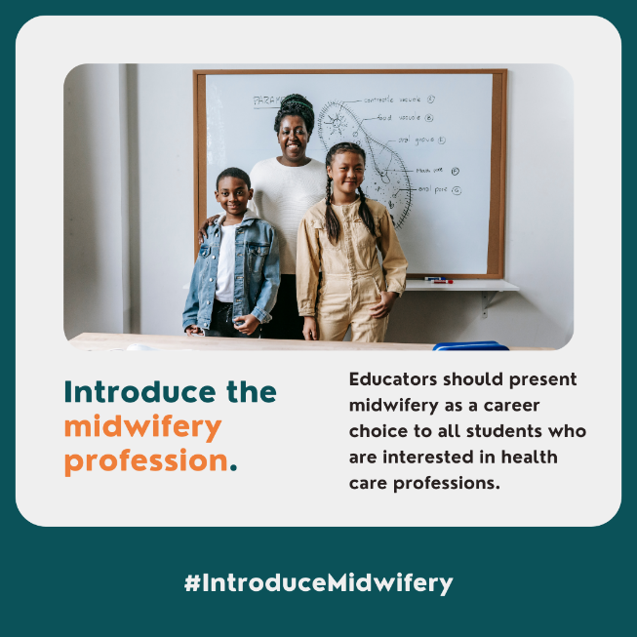

- Educators can inspire their students to become future midwives and enter the midwifery workforce. Support midwifery education by talking about the profession with your students today! #IntroduceMidwifery #InspireFutureMidwives #FutureMidwives #Midwifery
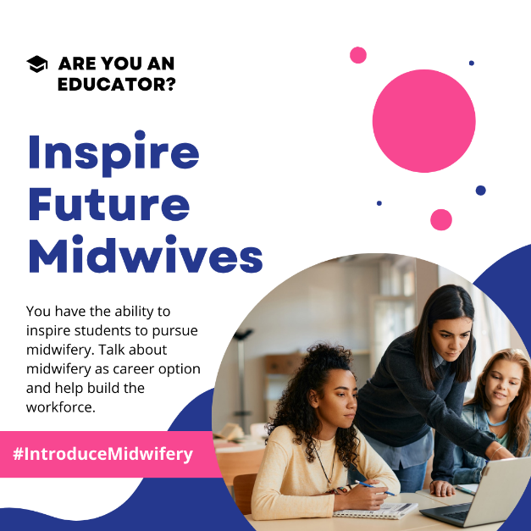

- In New Jersey and across the United States, midwifery is an underutilized resource. In other countries, midwives are the standard providers of care and are trained to provide a range of services including primary care, reproductive health, gynecologic care, and family planning services, and more. Countries with higher levels of midwifery integration have better health outcomes for mothers, infants, and families. #IntroduceMidwifery
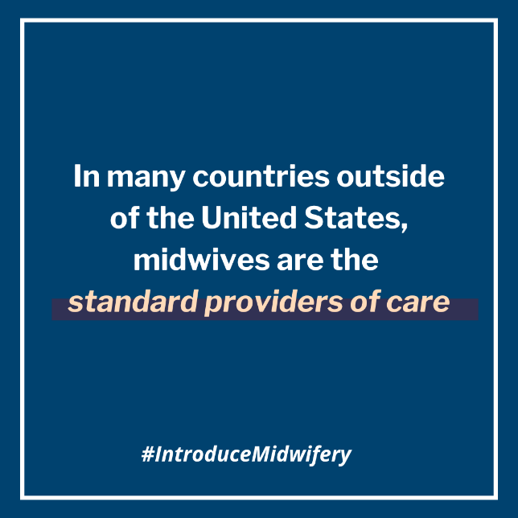

- Diversifying the midwifery workforce is crucial to address racial disparities and provide culturally congruent care to all birthing people. Educators can invest in the midwifery workforce by reaching diverse, BIPOC students and encouraging them to learn more about the midwifery profession. #IntroduceMidwifery #EducatorsIntroducingMidwifery #SupportMidwiferyWorkforce #FutureMidwives
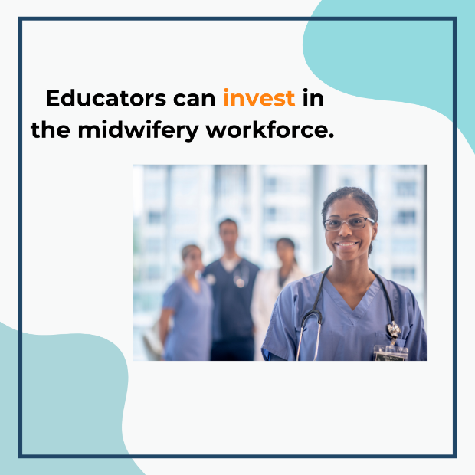

- Educators who are informed about a midwife’s full scope of education and training are better prepared to introduce the profession to their students. Midwives are health care providers who can provide care across the lifespan, including pregnancy, labor, postpartum, and menopause. Midwives are experts in well-woman care and work with other health professionals to improve birthing outcomes. #IntroduceMidwifery #EducatorsIntroducingMidwifery #FutureMidwives #AdvocateforMidwifery
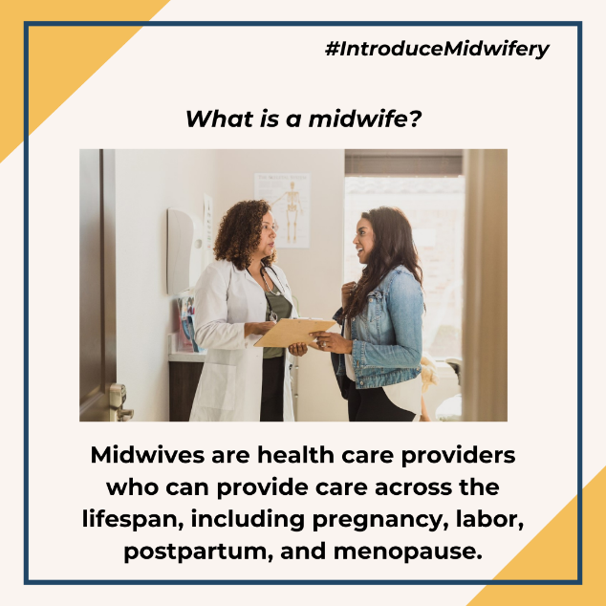

Resources
For additional resources on midwifery practice, please refer to the following sources:
- The New Jersey Health Care Quality Institute and Burke Foundation’s Approaches for Modernizing the Midwifery Profession: New Jersey's Regulatory and Licensing Structure report: https://njhcqi.info/modernizemidwifery0424.
- The New Jersey Health Care Quality Institute and Burke Foundation’s Delivering Better Care: Midwifery Practice in New Jersey report: https://njhcqi.info/MidwiferyReport062022
- The Maternal Infant Health Hub’s resource page: https://njhcqi.info/MIHHub.

