SOCIAL MEDIA TOOLKIT

Midwifery for Health Care Providers: Midwifery in Team-Based Care
Call to Action
The term “midwife,” (mid-wife) originates from old English, meaning with woman. Midwives are health care providers who provide care during pregnancy, childbirth, and the postpartum period—and also provide reproductive and primary health care at every life stage, including routine gynecologic care, annual exams, family planning services, and contraception education. Midwives use the midwifery model of care, which is a philosophy that views pregnancy and childbirth as normal life events and emphasizes person-centered care.
Although midwives are an essential part of the health care workforce, their work is often misunderstood, underused, and undervalued. The United States has the highest maternal mortality rates of any high-income country. In New Jersey, a Black woman is seven times more likely to die of pregnancy or birth issues than a white woman, and a Black baby is three times more likely than a white baby to die before their first birthday. In most of the higher income countries with better maternal health outcomes, midwifery-led care is the norm. Here in New Jersey, midwives have a key role in eliminating the state’s intolerable disparities.
This toolkit provides education and sample social media posts to raise health care providers’ awareness on the importance of midwifery care integration and interprofessional collaboration. Together, midwives, physicians, nurses, doulas, and other key professionals can work together to address maternal health disparities and provide optimal care to birthing people and their families.
Instructions: This toolkit contains key messages, social media posts, and graphics that promote midwifery messaging for consumers. Please share this content through your social media platforms and tag the New Jersey Health Care Quality Institute and the Burke Foundation in your advocacy efforts to support and expand access to midwifery. You may also include your own social media handles, graphics, and hashtags as you customize each message to your liking. Together, let’s amplify that health care providers should support interprofessional collaboration with midwives: #TeamBasedCare.
Key Messages for Health Care Providers

• What is a Midwife: Midwives are health care providers who can provide care throughout pregnancy, childbirth, postpartum, and menopause. Beyond pregnancy, their scope of practice also includes providing primary care, reproductive health, gynecologic care, annual exams, and family planning services, including preconception care. Midwives are experts in physiologic birth and work in a variety of settings including hospitals, clinics, birth centers, or at home.

• Pathways into Midwifery: Educators should emphasize that there are several pathways into midwifery. In New Jersey, Certified Nurse Midwives (CNMs), Certified Midwives (CMs), and Certified Professional Midwives (CPMs) are licensed to practice in the state.
- CNMs: To become a CNM, an individual must have a degree in nursing and then complete a master’s or doctoral degree in a program accredited by the Accreditation Commission for Midwifery Education (ACME), and then pass the national Certified Nurse Midwife exam administered by the American Midwifery Certification Board (AMCB) to become board certified.
- CMs: To become a CM, an individual must have a bachelor’s degree in a subject other than nursing, and then complete a master’s degree in midwifery in a program accredited by the ACME. CMs must also pass the national qualifying exam from the AMCB to become board certified.
- CPMs: There are multiple pathways to become CPMs. The first option is to train through an apprenticeship with a qualified midwife, and then complete an Entry-Level Portfolio Evaluation Process (PEP). The second pathway is to attend a midwifery program or school accredited by the Midwifery Education Accreditation Council (MEAC), which may or may not confer a degree. Completion of either pathway qualifies applicants to sit for the NARM skills and written examinations to obtain Certified Professional Midwife status.
For more information about the pathways into midwifery, please refer to: https://njhcqi.info/MidwiferyReport062022.

• Evidence-Based Midwifery Model of Care: Midwives use an evidence-based model of care, which views pregnancy and childbirth as natural processes. The midwifery model of care supports shared decision-making and establishes the birthing person as an active partner in their health care. The midwifery model of care also allows midwives to prioritize respectful, culturally sensitive care that is individualized for the birthing person.

• Data Outcomes for Midwifery Care: Research shows that midwifery care can lead to better outcomes for birthing people, including reduced rates of cesarean sections, reduced neonatal deaths and preterm births, increased breastfeeding success, and increases in spontaneous vaginal births. Midwifery care also improves patient satisfaction and lowers health care costs. On average, the cost of childbirth for a low-risk pregnant person using midwife services was $2,262 less than births of this same low-risk demographic that used obstetrician care instead.

• Interprofessional Collaboration: Interprofessional collaboration describes the process of health care professionals working together to provide comprehensive person-centered care. Midwives, obstetricians, nurses, and other health care professionals can work together with the shared goal of providing safe, patient-centered care for birthing people and their families. Integrating midwifery care in team-based care ultimately addresses health disparities, improves the quality of care, and enhances childbirth experiences.

Social Media Campaign
Handles:
- Twitter & Facebook:
  - @NJHCQI
  - @BurkeFoundation
- LinkedIn:
  - @New Jersey Health Care Quality Institute
  - @The Burke Foundation
- Instagram:
  - @the_quality_institute_nj

Hashtags (If you would like to include):
#TeamBasedCare #MidwiferyIntegration, #IntegratedCare, #Collaboration, #Teamwork #InterprofessionalCollaboration, #MidwivesMatter, #MidwiferyCare, #Midwifery, #Midwife #Midwives, #AutonomousMidwifery, #MidwifeServices, #MaternalHealth, #NewJersey, #NJ, #WomensHealth
Website to Drive Traffic:
https://njhcqi.info/MIHHub

Social Media Posts

This social media kit contains sample posts you can easily customize, as well as images for you to include in your posts.
- Research shows that midwifery care leads to positive outcomes including reduced rates of cesarean sections, neonatal deaths, and preterm births. Midwifery care also improves patient satisfaction and lowers health care costs. #TeamBasedCare #MidwiferyIntegration #MidwiferyCare
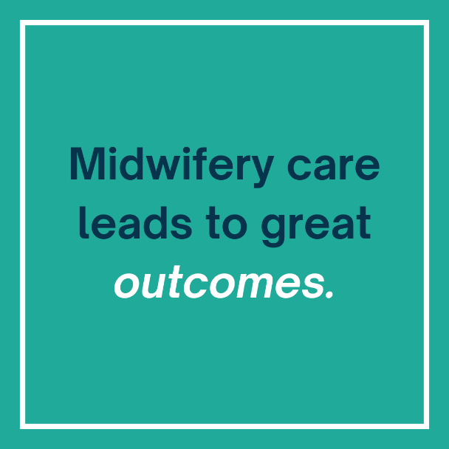

- Teamwork between midwives and other professionals can improve communication, increase job satisfaction, and promote evidence-based decision-making. #TeamBasedCare #MidwiferyIntegration #IntegratedCare #InterprofessionalCollaboration #Teamwork #MidwiferyCare
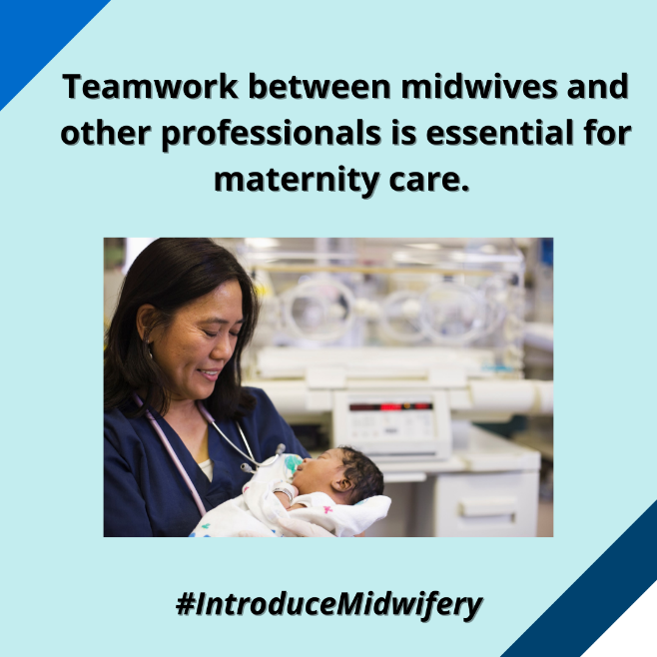

- Barriers such as restrictive legislation, lack of funding for midwifery education, and inequitable reimbursement must be eliminated to support full midwifery integration in our health care system. Midwives must be granted full practice authority to expand access to midwifery care. #TeamBasedCare #MidwiferyIntegration #IntegratedCare #InterprofessionalCollaboration #AutonomousMidwifery #MidwivesMatter
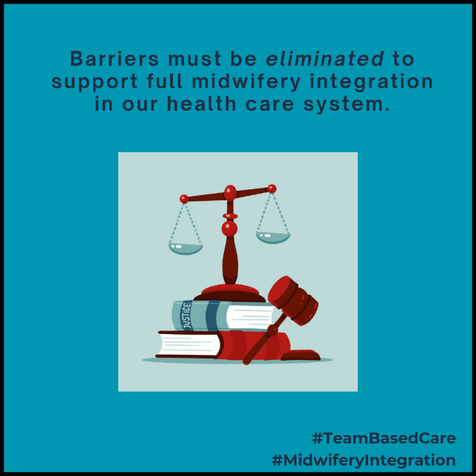

- Midwifery integration in our health care system impacts maternal infant health outcomes. States with higher levels of midwifery integration have improved outcomes compared to those with lower levels. #MidwiferyIntegration #TeamBasedCare #IntegratedCare #InterprofessionalCollaboration #Teamwork #MidwiferyCare
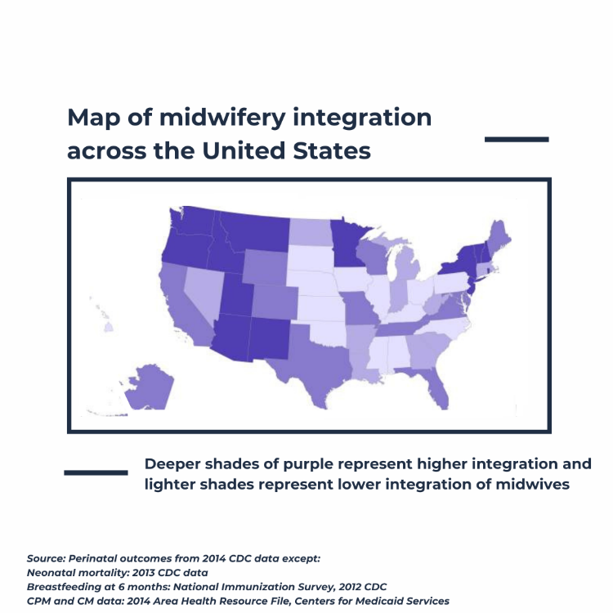

- Midwives are health care providers who can provide care across the lifespan, including pregnancy, labor, postpartum, and menopause. Beyond pregnancy, their scope of practice also includes providing primary care, reproductive health, gynecologic care, and family planning services, and more. #TeamBasedCare #MidwiferyIntegration #MidwivesMatter #MidwiferyCare
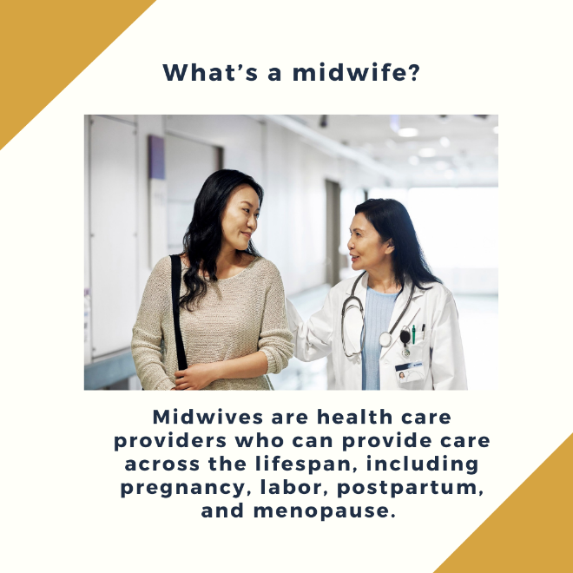

Additional Resources

For additional resources on midwifery practice, please refer to the following sources:
- The New Jersey Health Care Quality Institute and Burke Foundation’s Approaches for Modernizing the Midwifery Profession: New Jersey's Regulatory and Licensing Structure report: https://njhcqi.info/modernizemidwifery0424.
- The New Jersey Health Care Quality Institute and Burke Foundation’s Delivering Better Care: Midwifery Practice in New Jersey report: https://njhcqi.info/MidwiferyReport062022
- The Maternal Infant Health Hub’s resource page: https://njhcqi.info/MIHHub.
- American College of Obstetricians and Gynecologists (ACOG)’s position statement regarding midwifery: https://www.acog.org/advocacy/policy-priorities/midwifery

